Active Birth Pools
Ergonomics Appraisal
Assessment of the experience of mothers and midwives
as they move, interact and work with the pool

1. Executive Summary
Active Birth Pools demonstrate a high level of consideration for ergonomics and human factors.
The pools have evidently been developed around the physical, emotional and operational needs of the principal users: mothers, midwives, birth partners and maternity-support staff.
From an ergonomics perspective, the strongest aspect of the design is that the pool is treated not simply as a vessel containing water, but as a shared clinical workspace in which the mother and midwife must remain physically and socially connected.
The design supports mothers in adopting and changing between a wide variety of labour positions.
At the same time, the external form, wide rim and clear working perimeter allow midwives to remain closer to the mother while adopting more comfortable and stable working postures.

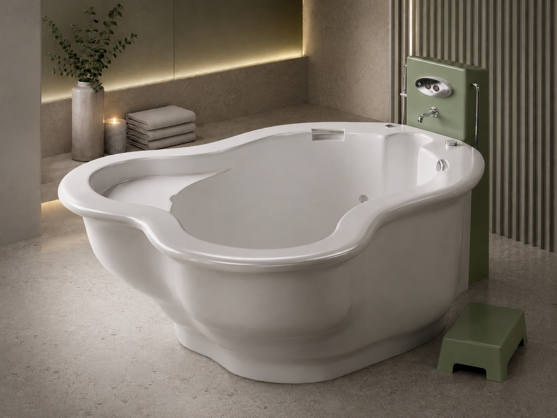

Particularly beneficial features include:
- The concave external surround, which provides knee and leg clearance for seated midwives.
- The extra-wide, rounded rim, which supports the arms of midwives and provides mothers with a continuous handhold.
- Interior seats, contours and hand supports that assist mothers in resting, kneeling, squatting and adopting upright postures.
- A relatively uncluttered rim and pool perimeter, allowing midwives to move and reposition themselves as care requirements change.
- Entry and exit arrangements that encourage controlled movements rather than climbing over a narrow pool wall.
- Design provisions intended to facilitate emergency evacuation.
- Freestanding 360-degree models that can improve access from multiple sides.
- The overall design is likely to reduce many of the awkward postures and access difficulties commonly associated with conventional, vertically sided birth pools. It should help mothers feel more physically secure while enabling midwives to work closer to the mother with less sustained forward bending.

Subject to confirmation through practical user trials, Active Birth Pools have been assessed as demonstrating a very good standard of user-centred ergonomic design, with particular strengths in maternal movement, midwife access and the quality of interaction between mother and caregiver.

2. Scope and Basis of Assessment
This appraisal considers the principal movements and interactions undertaken by mothers and midwives when using an Active Birth Pool.
It focuses on entering and leaving the pool, moving and changing position within the pool, resting and maintaining supported postures, interaction between the mother and midwife, midwife observation and examination, access during birth, emergency access and evacuation, movement around the pool, and the influence of the pool on communication, reassurance and care.
This is a desk-based expert appraisal based on published product information, technical data and photographs.
It has not included direct observation of pools in clinical use, measurements of users' working postures, interviews with mothers or midwives, or simulated emergency trials.
The findings should therefore be regarded as an informed ergonomic assessment of the design rather than a substitute for a full clinical user study.

3. Users and Ergonomic Requirements

3.1 The Mother
The mother may use the pool for an extended period while experiencing changing levels of mobility, strength, balance, discomfort and fatigue.
Her ergonomic requirements include safe and dignified entry and exit, freedom to move without feeling confined, reliable support when changing position, opportunities to rest without leaving the water, support for upright, kneeling, seated, leaning and squatting positions, surfaces that feel secure and comfortable against the body, the ability to maintain contact with the midwife and birth partner, and rapid assistance if her condition changes.
The mother should not be expected to adapt herself to the pool.
The pool should accommodate her changing physical and emotional needs throughout labour.

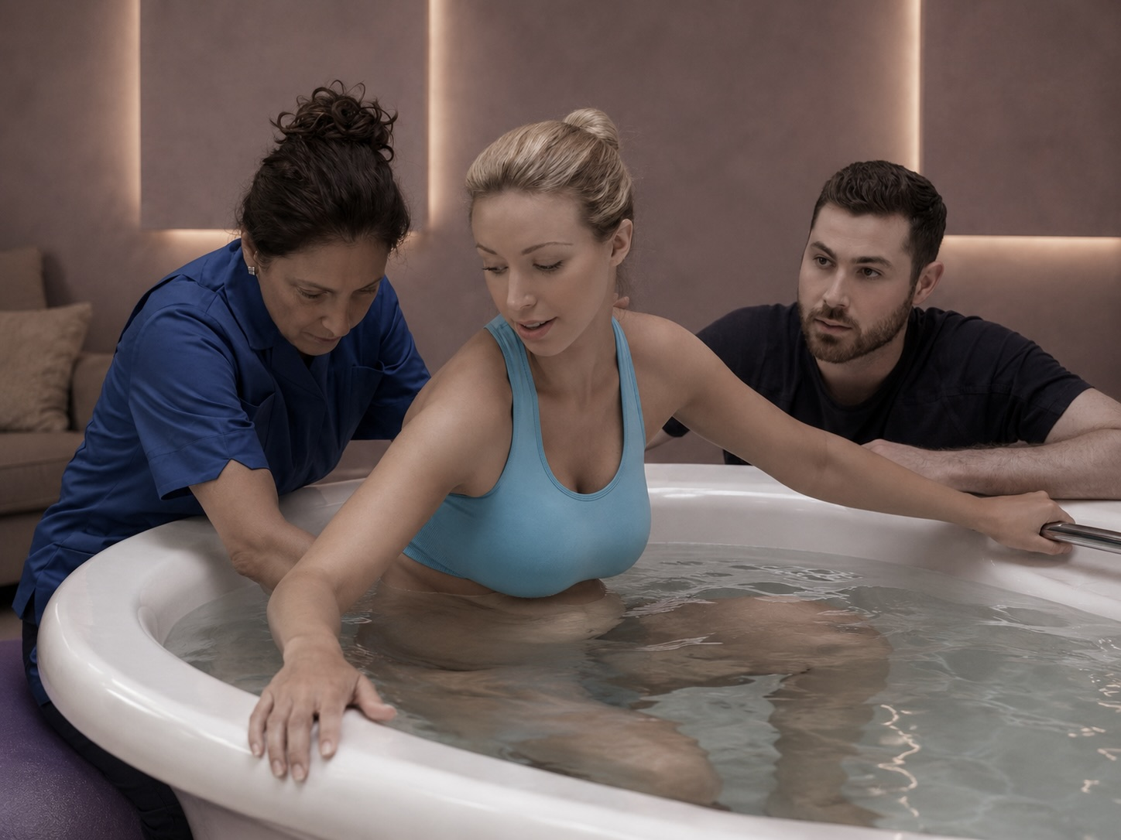

3.2 The Midwife
The midwife's tasks vary considerably and may include prolonged observation, conversation, reassurance, fetal monitoring, maternal assessment, assisting movement, supporting the birth and responding to emergencies.
Her ergonomic requirements include the ability to get close to the mother, adequate leg and knee clearance, supported working postures, the ability to change position regularly, reasonable reach to relevant parts of the pool, clear visibility of the mother and baby, unobstructed movement around the pool, space for equipment and additional staff when required, and safe procedures for emergency intervention.
Unlike the mother, who may use the pool occasionally, midwives may work with birth pools repeatedly throughout their careers.
Even comparatively minor awkward postures could therefore contribute to cumulative discomfort or musculoskeletal risk.

3.3 Mother-Midwife Interaction
The mother and midwife form a shared working system.
The pool should support physical access without undermining the mother's privacy, calm or sense of control.
A good ergonomic design should allow the midwife to remain close and attentive without appearing to loom over the mother or repeatedly invade her space.
It should also allow the mother to move towards the midwife when she requires reassurance or assistance.

4. Assessment of the Mother's Experience
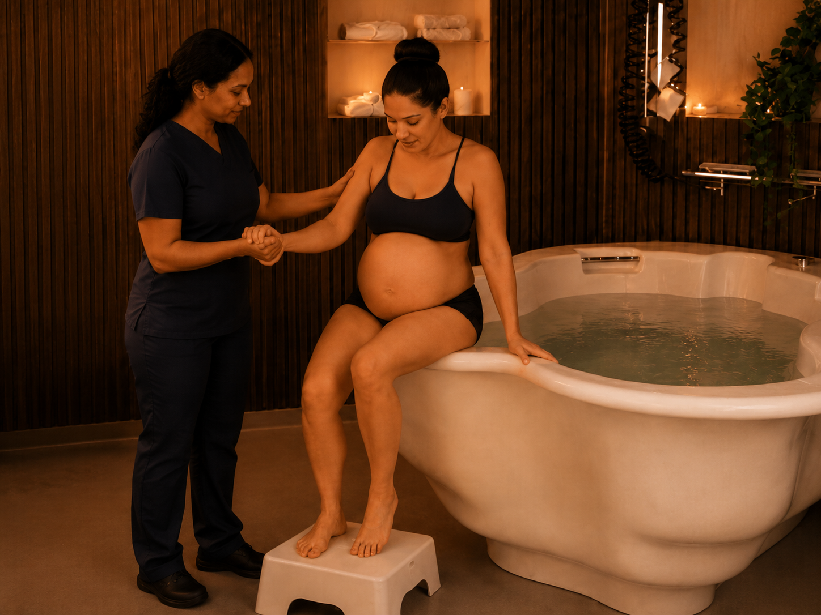

4.1 Entry into the Pool
Entering a birth pool presents an inherent balance and manual-handling challenge.
The mother may be experiencing contractions, reduced confidence, fatigue or altered mobility. Wet surfaces may further increase risk.
The wide pool rim provides a large and relatively stable surface onto which the mother can sit before rotating and lowering herself into the water.
This sit-and-swivel movement is ergonomically preferable to stepping directly over a high, narrow wall because it reduces the requirement to balance momentarily on one leg.
The sequence allows the movement to be divided into controlled stages: approach the pool; use the step or support where required; sit on the wide rim; rotate the legs into the pool; and lower into the water using the rim and internal supports.
This method is likely to reduce anxiety and enable the midwife or birth partner to assist without lifting the mother's full body weight.
The wide rim also accommodates a greater range of body sizes than a narrow edge. wIt provides a more substantial seating surface and should reduce localised pressure on the mother's legs during entry.
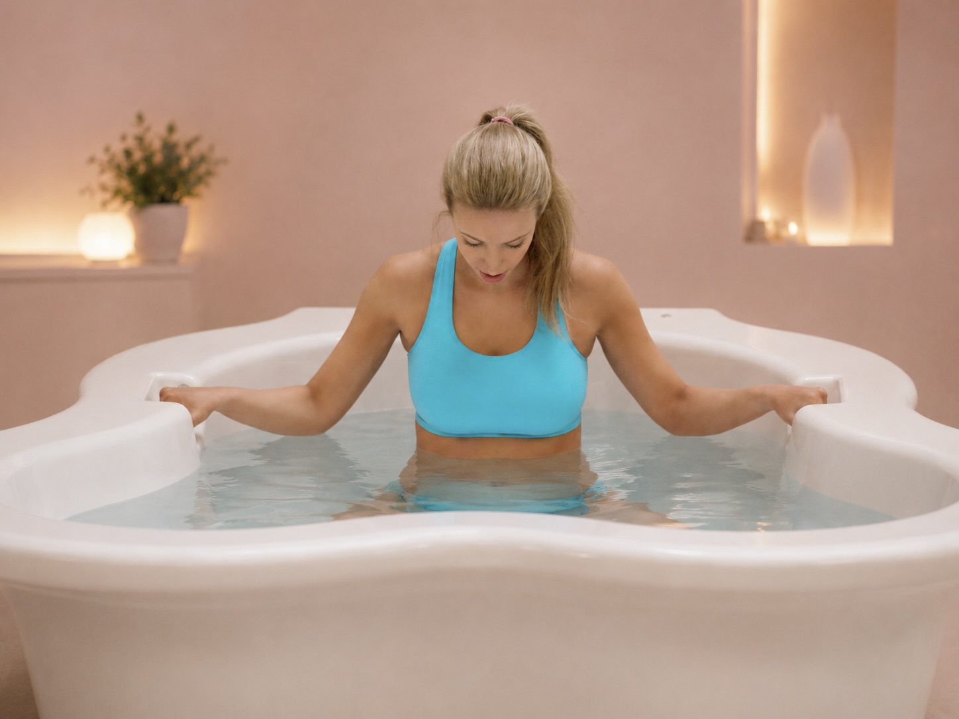

4.2 Movement Within the Pool
The internal dimensions and depth allow the mother to benefit from buoyancy while moving between positions.
The water reduces effective body weight, which should make it easier to rotate, kneel, squat and move between seated and upright postures.
The pool's rounded form avoids visually or physically confining the mother to one orientation.
She can move in response to comfort, instinct and the progression of labour rather than being required to face a fixed direction.
A continuous rounded rim provides a handhold around much of the pool.
This is an important ergonomic advantage because the mother does not have to locate a small or isolated grab handle before changing position.
She can reach towards the nearest section of rim and use it for balance or leverage.
The recessed hand-support features provided on some models offer additional support for upright or squatting positions while avoiding unnecessary projections into the pool.
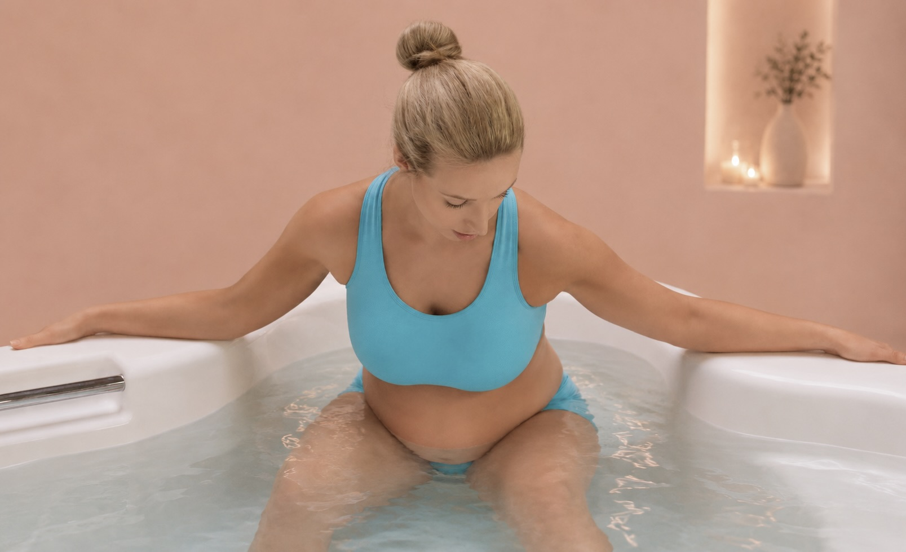

4.3 Supported Labour Positions
The internal support seat and sculpted contours provide options for resting and for maintaining upright postures.
The support seat may assist mothers who wish to remain upright but require periods of rest.
It can also act as a transitional surface when moving between sitting, kneeling and standing.
The design of the Venus support seat, including the central groove, appears intended to avoid concentrated pressure around the sacrum and preserve freedom around the pelvis.
From an ergonomic standpoint, this is preferable to a broad, flat seat that could restrict movement or encourage a fixed reclined posture.
Lumbar-support features and internal contours may also help the mother maintain supported squatting or leaning positions with less muscular effort.
The pool therefore provides a range of physical affordances: its shape communicates possible ways of using it without requiring complicated instructions.
The mother can intuitively hold, lean, sit, kneel or brace against different parts of the pool.
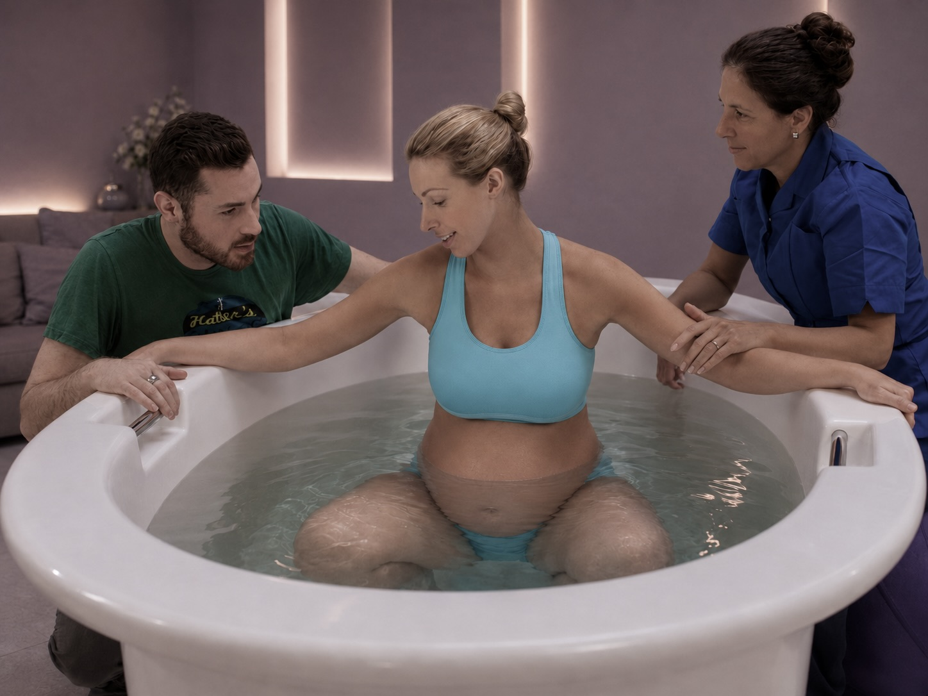

4.4 Comfort and Sense of Security
The broad, curved rim is likely to feel more comfortable against the arms, chest, shoulders or head than a narrow or sharply defined edge.
The ability to lean onto the rim may be particularly valuable during contractions.
A continuous support surface can also contribute to psychological security.
Wherever the mother moves within the pool, a substantial handhold or leaning surface remains within reach.
The use of a smooth, tactile and reportedly less-slippery material should improve comfort and confidence.

4.5 Maternal Control and Autonomy
The pool's design generally allows the mother to move independently rather than repeatedly asking staff to reposition equipment or assist her into prescribed postures.
This supports maternal autonomy and may reduce unnecessary physical intervention by midwives.
It also allows the mother to remain actively involved in decisions about her posture and comfort.
Lighting and sound options may allow the environment to be personalised.These can contribute to relaxation, although ambient lighting should never reduce the midwife's ability to visually assess the mother or baby.

5. Assessment of the Midwife's Experience

5.1 Access to the Mother
The external concave surround is a particularly significant ergonomic feature.
Conventional pools with vertical external walls prevent a seated midwife from bringing her knees and feet close to the pool.
The midwife must either remain further away and reach forwards or sit with her legs spread around the pool wall.
The concave surround provides space for the midwife's knees and lower legs beneath the rim.
This allows her trunk to remain closer to upright while her chair or stool is positioned nearer to the mother.

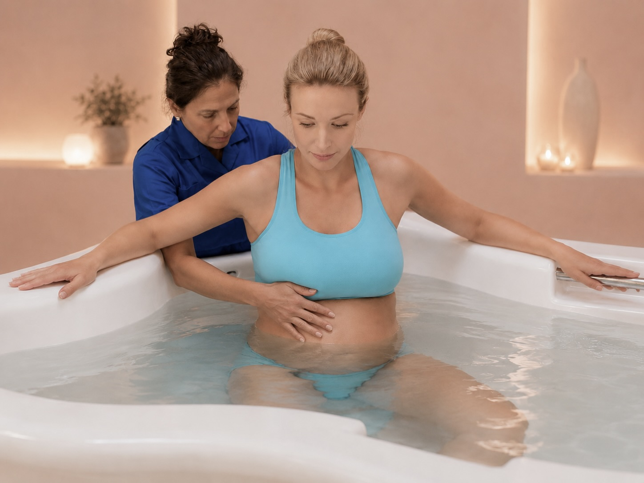
5.2 Forearm and Upper-Body Support
The extra-wide rim allows midwives to rest their forearms while observing, speaking with or attending to the mother.
Forearm support can reduce the muscular effort needed to maintain the arms in front of the body.
It may also allow the midwife to lean closer while remaining stable.
The rounded rim distributes pressure across a larger area than a narrow edge.
This improves comfort during prolonged contact and reduce localised pressure on the forearms.

5.3 Movement Around the Pool
An uncluttered rim allows midwives to reposition themselves without negotiating taps, spouts or prominent fittings.
This supports task flexibility and reduces the risk of bumping, snagging clothing or adopting an unsuitable position simply because the preferred working area is obstructed.
Freestanding 360-degree models provide the greatest potential access, allowing staff to approach the mother from multiple directions.
This can reduce twisting and overreaching and may be particularly beneficial when additional assistance is required.
The practical benefit of 360-degree access depends on the room layout.
Sufficient clearance must be maintained around the pool, and the space must not become occupied by furniture, equipment, bags or portable steps.
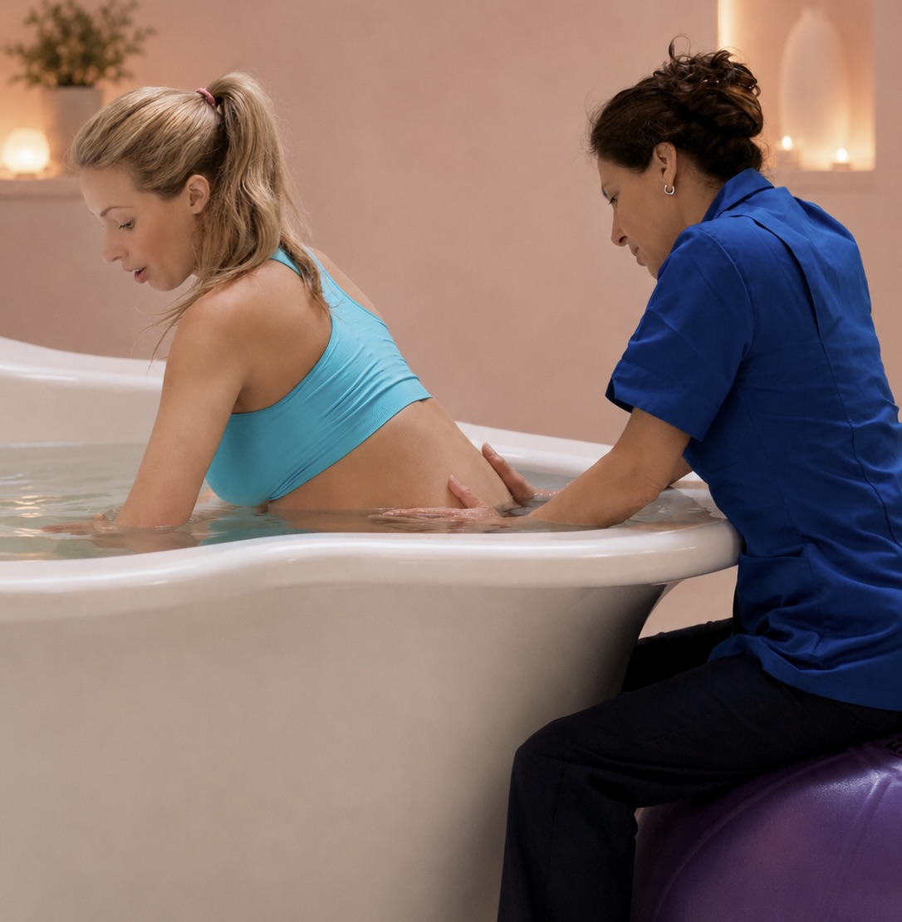

5.4 Seated, Kneeling and Standing Work
The pool supports seated attendance particularly well. Nevertheless, different tasks will require different working heights and positions.
Midwives may alternate between sitting beside the pool, standing and leaning onto the rim, kneeling beside the pool, moving around the pool, reaching into the water, and supporting the mother during entry or exit.
No single posture should be maintained for excessive periods.
Suitable adjustable-height seating and sufficient floor space should be considered part of the complete ergonomic system.
The pool itself provides good opportunities for support, but the surrounding furniture and room design determine whether midwives can make effective use of these opportunities.
6. Mother-Midwife Interaction

6.1 Physical Proximity
The pool's external shape allows the midwife to sit close to the mother without the pool wall forming a substantial physical barrier.
This can improve communication and reassurance.
The midwife can maintain eye contact, speak quietly and offer a hand or physical support without repeatedly standing or leaning across the pool.
The wide rim creates a shared surface between the mother and midwife.
The mother may lean on the inside of the rim while the midwife rests her arms on the outside. This arrangement supports closeness while preserving a comfortable boundary.
6.2 Supporting Movement Without Lifting
The design allows the midwife to guide or steady the mother using the rim, step, support seat and surrounding handholds rather than physically lifting her.
This is important because manual lifting of a labouring mother presents a significant risk to both parties.
Supporting controlled, self-initiated movement is preferable wherever clinically appropriate.
The pool encourages the midwife to provide verbal guidance, light stabilising support and reassurance while the mother uses the pool's features to complete the movement herself.

6.3 Maintaining Dignity and Control
The pool allows the mother to remain the principal actor while the midwife remains accessible.
This balance is ergonomically and psychologically valuable.
The midwife can observe and intervene when required without unnecessarily directing the mother's posture or dominating the space.
The mother can move closer to or further away from the midwife according to her needs.

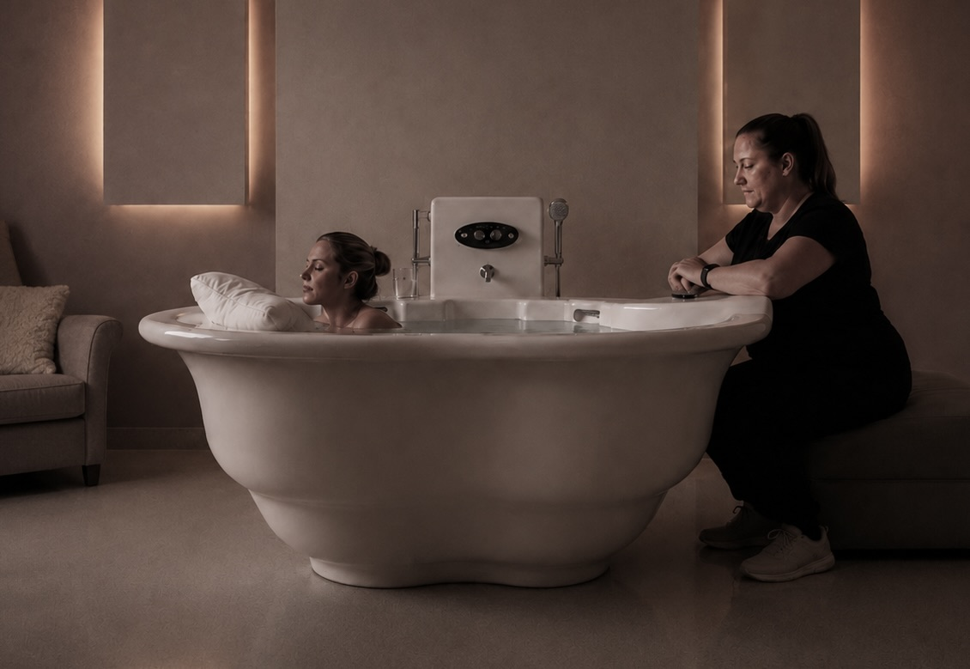

7. Emergency Access and Evacuation
Emergency procedures represent the most demanding interaction between the mother, midwife, pool and surrounding room.
The wide rim and integrated seating features appear to provide surfaces onto which a mother may be supported or moved during an emergency.
The pool design also allows evacuation with a portable hoist where required.
From an ergonomics perspective, the objective should be to avoid staff attempting to lift a collapsed or non-weight-bearing mother vertically out of the water using manual effort alone.
The pool's design can support safer procedures. Emergency simulations should be undertaken using the installed pool and actual room layout.
These should include realistic constraints such as wet floors, restricted space, different maternal positions and the presence of clinical equipment.

8. Overall Ergonomic Assessment
Active Birth Pools demonstrate a clear and credible application of user-centred ergonomic principles.
The design responds directly to the principal limitations of traditional birth pools: difficult entry and exit, inadequate maternal support, poor midwife access, restricted knee clearance and excessive reaching over vertical pool walls.
The interaction between the concave external surround and extra-wide rounded rim is particularly effective.
Together, these features allow midwives to sit closer, support their upper limbs and maintain a more stable posture while remaining connected to the mother.
Internally, the pool provides mothers with a versatile and supportive environment that facilitates movement rather than prescribing a limited number of positions.
The continuous rim, support seats, internal contours and water depth create multiple opportunities for mothers to hold, lean, sit, kneel and squat.
The freestanding 360-degree models provide the greatest access flexibility, although their benefit depends on sufficient room space being maintained.
The design cannot eliminate every instance of bending, reaching or manual-handling risk, particularly during complex clinical tasks or emergencies.
Nevertheless, it is likely to reduce the frequency and severity of many awkward working postures when compared with conventionally shaped birth pools.
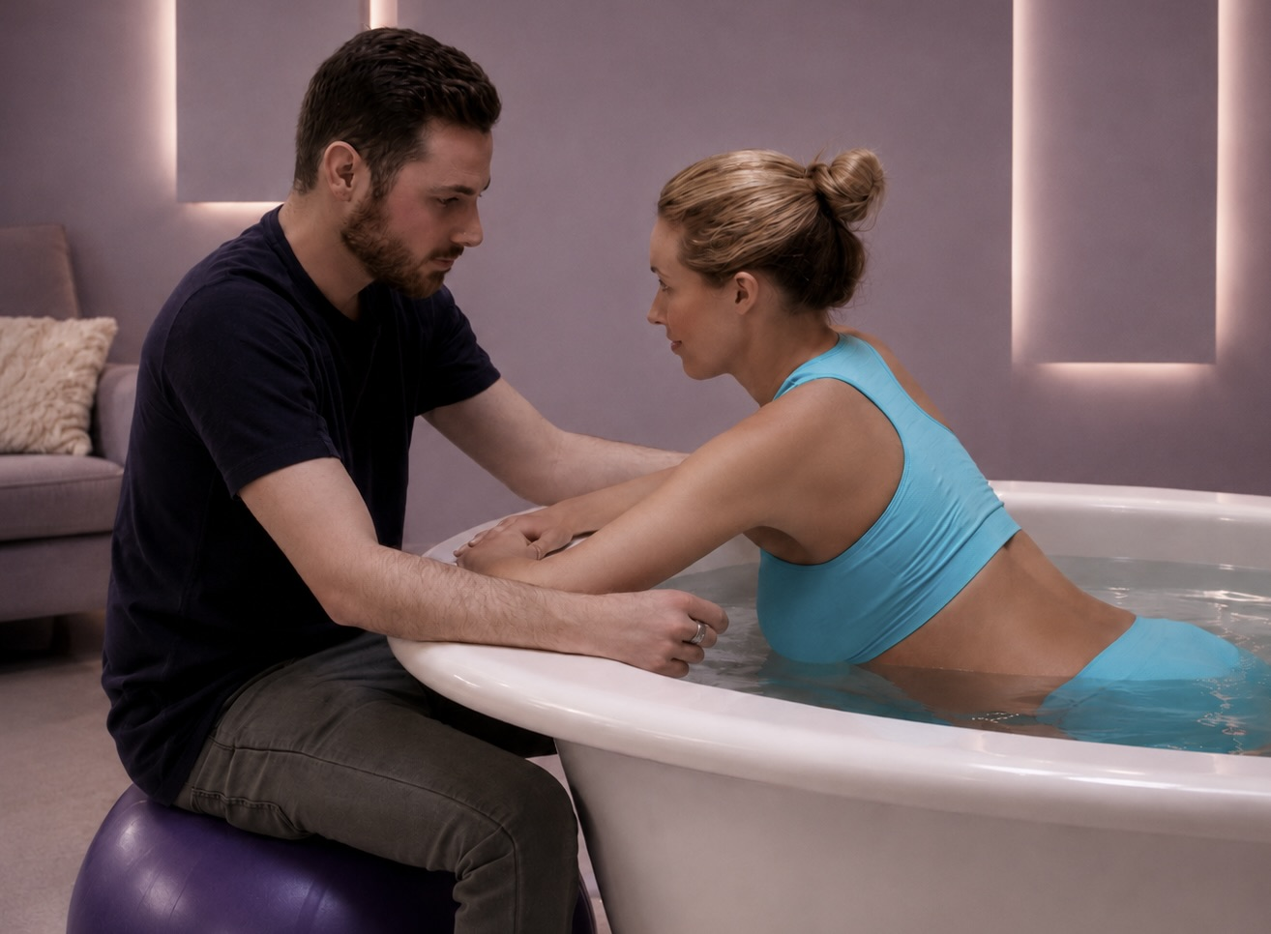

9. Ergonomic Rating
Assessment area | Provisional rating
Maternal movement and postural support | Very good
Entry and exit | Very good, subject to appropriate step placement and procedures
Midwife seated access and comfort | Very good
Midwife reach and task access | Good to very good, dependent on model and room layout
Mother-midwife interaction | Very good
Emergency-access potential | Good to very good, subject to local procedures and simulation
Overall user-centred design | Very good

10. Conclusion
Active Birth Pools provide a well-considered ergonomic environment for labour and birth in water.
The design supports mothers' freedom of movement while enabling midwives to remain physically close, comfortable and responsive.
The pool's form encourages a collaborative relationship between mother and midwife.
Rather than separating them, the design creates a shared, supportive working space in which the mother can move naturally and the midwife can provide care with reduced physical obstruction.
Active Birth Pools may be regarded as a strong example of how ergonomics and human factors can improve the safety, comfort and experience of both service users and healthcare professionals.

11. References
1. International Organization for Standardization. ISO 26800:2011 Ergonomics - General approach, principles and concepts. Geneva: ISO; 2011. Standard reviewed and confirmed in 2022. Available at: https://www.iso.org/standard/42885.html (accessed 17 July 2026).
2. Jones A. Manual handling risks to midwives associated with birthing pools: literature review and incident analysis. HSE Research Report RR1132. Buxton: Health and Safety Executive; 2018. Available at: https://www.hse.gov.uk/research/rrpdf/rr1132.pdf (accessed 17 July 2026).
3. Health and Safety Executive. Moving and handling in health and social care: manual handling in birthing pools. Updated 12 January 2026. Available at: https://www.hse.gov.uk/healthservices/moving-handling/birthing-pools.htm (accessed 17 July 2026).
4. Department of Health and NHS England. Health Building Note 09-02: Maternity care facilities. London: Department of Health; 2013. Publication page updated 31 January 2024. See especially paragraphs 8.15-8.18 on birthing-pool areas and ergonomic assessment. Available at: https://www.england.nhs.uk/publication/maternity-care-facilities-planning-and-design-hbn-09-02/ (accessed 17 July 2026).
5. National Institute for Health and Care Excellence. Intrapartum care. NICE guideline NG235. Published 29 September 2023; water-birth recommendations amended 2025. See recommendations 1.4.12 and 1.6.10-1.6.13. Available at: https://www.nice.org.uk/guidance/ng235/chapter/Recommendations (accessed 17 July 2026).
6. World Health Organization. WHO recommendations: intrapartum care for a positive childbirth experience. Geneva: WHO; 2018. Available at: https://www.who.int/publications/i/item/9789241550215 (accessed 17 July 2026).
7. Cluett ER, Burns E, Cuthbert A. Immersion in water during labour and birth. Cochrane Database of Systematic Reviews. 2018;(5):CD000111. doi:10.1002/14651858.CD000111.pub4.
8. Burns EE, Feeley C, Hall PJ, Vanderlaan J. Systematic review and meta-analysis to examine intrapartum interventions, and maternal and neonatal outcomes following immersion in water during labour and waterbirth. BMJ Open. 2022;12:e056517. doi:10.1136/bmjopen-2021-056517.
9. Feeley C, Cooper M, Burns E. A systematic meta-thematic synthesis to examine the views and experiences of women following water immersion during labour and waterbirth. Journal of Advanced Nursing. 2021;77:2942-2956. doi:10.1111/jan.14720.
10. Nowotny-Czupryna O, Naworska B, Brzek A, Nowotny J, Famula A, Kmita B, Bak K. Professional experience and ergonomic aspects of midwives' work. International Journal of Occupational Medicine and Environmental Health. 2012;25(3):265-274. doi:10.2478/S13382-012-0034-6.
11. Hasheminejad N, Amirmahani M, Tahernejad S. Biomechanical evaluation of midwifery tasks and its relationship with the prevalence of musculoskeletal disorders. Heliyon. 2023;9(9):e19442. doi:10.1016/j.heliyon.2023.e19442.
12. Health and Safety Executive. Managing the risk of slips and trips in health and social care. Updated 12 January 2026. Available at: https://www.hse.gov.uk/healthservices/slips/what-you-need-to-do.htm (accessed 17 July 2026).
13. Health and Safety Executive. Moving and handling equipment in health and social care. Updated 13 January 2026. Available at: https://www.hse.gov.uk/healthservices/moving-handling/moving-handling-equipment.htm (accessed 17 July 2026).
14. Torres-Ronda L, Schelling X. The properties of water and their applications for training. Journal of Human Kinetics. 2014;44:237-248. doi:10.2478/hukin-2014-0129.
15. Active Birth Pools. Active Birth Pools Catalogue. London: Active Birth Pools; 2025. Product-specific source for pool geometry, concave surround, rim, internal supports and Ficore® comparative material claims. Available at: https://activebirthpools.com/wp-content/uploads/2025/02/Active-Birth-Pools-Catalogue-.pdf (accessed 17 July 2026).
16. Active Birth Pools. Water birth pool data sheets and current product pages for Active II/360, Venus II/360 and Princess II/360 models. London: Active Birth Pools; 2026. Product-specific source for dimensions, support-seat features, access configurations and installation arrangements. Available at: https://activebirthpools.com/data-sheets-plans-and-3d-models/ (accessed 17 July 2026).

